

Dashboard UI Backend & Frontend
Description

For

Verizon Data Orchestration

Document Version: 1.0

Date: [1/9/2023]

1. Overview 3
2. Backend details 3
2.1 Version Details 3
2.2 Service Description 4
2.3 Backend Services 5
3. Introduction To ASN.1 5
3.1 Types of messages 6
3.2 Technology 8
3.3 Setup 8
3.4 Access, Authentication and Authorisation 9
4. Deployment 9
5. Frontend: ADOP-WEB 9
5.1 Version Details 9
5.2 Technology used 9
5.3 Setup 9
5.4 Frontend: Description 11
5.5 Communication flow in ADOP-WEB 14
5.6 Transaction Between Dashboard UI & Backend 15
5.7 Format Of Messages After Decoding 16
5.8 Details of Google APIs 18
6. Deployment 19
7. Map & SPAT Data Creation Summary 20

Overview
This document describes all the technical aspects of the data orchestration application.
The main motive of the application is to facilitates user to get the fined information about the lane or street in which they are travelling.

Backend details

Version Details

Please document all changes made to this document since initial distribution.

Version | Amendment
1.0.0 | Middleware setup to communicate with Verizon VZ server and mediate to Frontend.

Service Description
High level description of what this service does (a list of the major components).

This includes the technical processes and components used to deliver the solution, and flow diagram describing the process.
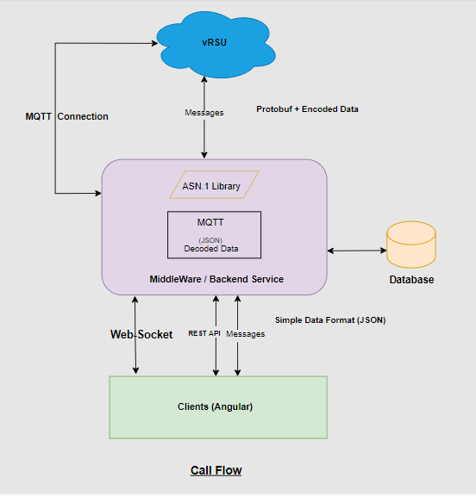
VRSU: It is the MQTT (Standard messaging protocol for IoT). Multiple publishers are publishing the data to MQTT through an android application. It serves as messaging queue service which is connected to Middle Ware or Backend Services.

MiddleWare or Backend Services: This layer is connected with VRSU through a very lightweight publish/subscribe system. It contains ASN Library, MQTT using decoded data, Backend services.

ASN library: Abstract Syntax Notation, is an International Standards Organization (ISO) data representation format used to achieve interoperability between platforms. It permits computers and software systems of all types to reliably exchange both the data structure and content.

MQTT decoded data: When subscribed to a particular topic, messages are being listened by backend services. All these messages are decoded here for further use.

Backend services: It mainly contains the REST APIs which send the representational state of the data in web sockets or through JSON type response.

Client (Angular): It is a web-based application reacts as a client for backend services. It provides detailed option for pedestrian counts, total emergency counts, total general vehicle.
It also have some bar graphs as a representation of data.

Backend Services
Vehicle-manager Service
This service is used to established the MQTT connection and web socket connection with the client. The context path of the service is /vrsu/api/subscriber
It sends the subscribed messages to client through web socket.
It has a Subscriber controller which contains the below APIs:
/mqttdata: Fetch all devices being connected to mqtt.
/login: Use to login the web application with credential validation.
/mqttConnectionCheck: Use to check the mqtt connection with the backend service.
/subscribeToTopic: This service api is used to subscribe a particular topic from MQTT.
/disconnect: API to get disconnected from mqtt.

Introduction To ASN.1
- Abstract Syntax Notation One (ASN.1) is a standard interface description language for defining data structures that can be serialized and deserialized in a cross-platform way.
- It is broadly used in telecommunications and computer networking, and especially in cryptography.
- Protocol developers define data structures in ASN.1 modules, which are generally a section of a broader standards document written in the ASN.1 language.
- ASN.1 is both human-readable and machine-readable, an ASN.1 compiler can compile modules into libraries of code, codecs, that decode or encode the data structures.
In the application we are using 2 encoding rules.
- UPER (Unaligned Packed Encoding Rules)
- JER (JSON Encoding Rules)

UPER: This Unaligned Packed Encoding are the most compact encoding rules. The goal of PER is to create smaller encodings. An advantage of using PER is the way it encodes data by examining constraints. PER does not send the Tag of the TLV since the order in which components of the message occur is known. PER also does not send the Length of the TLV if the Value has a fixed length. PER also uses additional information from the ASN.1 message description to eliminate redundant information from the Value portion of the TLV, thus making PER messages quite compact and suitable for environments in which bandwidth conservation is important.
For creation of UPER data, first we need to create a schema .
Let’s say my schema is,
BEGIN
FooBar ::= SEQUENCE {
Foo INTEGER (-512..511),
Bar INTEGER (-512..511)
}
END

Now, In case we need to encode below data:
test FooBar ::=
{
Foo 10,
Bar -10
}

It will be encoded as:
HEX: 0x829F60
BIN: 100000101001111101100000

Although, in our application we are directly using the ASN.1 libraries APIs to encode or decode the data.

JER: This JSON encoding rules was designed to allow applications to represent any ASN.1 value in JavaScript Object Notation (JSON). For example, an application that receives BER- or PER-encoded messages conforming to a certain ASN.1 schema will be able to re-encode the messages in JSON. This capability can be used to exchange data with other applications that do not understand ASN.1 but know how to parse or write JSON.
Below is the example of JER data for MAP being published to MQTT.

Types of messages
- BSM: The basic safety message (BSM) is used in a variety of applications to exchange safety data regarding vehicle state. This message is broadcast frequently to surrounding vehicles with data content as required by safety and other applications. Transmission rates are beyond the scope of this standard, but a rate 10 times per second is typical when congestion control algorithms do not prescribe a reduced rate.

- PSM: The Personal Safety Message (PSM) is used to broadcast safety data regarding the kinematic state of various types of Vulnerable Road Users (VRU), such as pedestrians, cyclists, or road workers. Data items which are optional are included in a PSM as needed according to policies that are beyond the scope of this standard.

- EVA: The emergency vehicle alert message is used to broadcast warning messages to surrounding vehicles that an emergency vehicle (typically an incident responder of some type) is operating in the vicinity and that additional caution is required. The message itself is built on the original ATIS roadside alert message which in turn uses the common ITIS phrase list to both describe the event and provide advice and recommendation for travellers.

- RSA: This message is for alerting about roadway hazards; not for vehicle cooperative communications, mayday, or other safety applications. It is generally presumed that each receiving device is aware of its own position and heading; but, it is neither a requirement to receive and understand these messages, nor is having a local base map.

- SPaT: The signal phase and timing (SPAT) message is used to convey the current status of one or more signalized intersections. Along with the MSG_MapData message (which describes a full geometric layout of an intersection), the receiver of this message can determine the state of the signal phasing and when the next expected phase will occur.MAP: The MapData message is used to convey many types of geographic road information. At the current time, its primary use is to convey one or more intersection lane geometry maps within a single message. The map message content includes such items as complex intersection descriptions, road segment descriptions, high speed curve outlines (used in curve safety messages), and segments of roadway (used in some safety applications).

- MapData: message may convey descriptions of one or more geographic areas or intersections. The contents of this message involve defining the details of indexing systems that are in turn used by other messages to relate additional information (for example, the signal phase and timing via the SPAT message) to events at specific geographic locations on the roadway.

For above messages, we are using an unique identifier Key. Based on that key, we are using those messages in dashboard UI.

SNo | Type of message | Key Identifier in JSON
1 | BSM | BasicSafetyMessage
2 | PSM | PersonalSafetyMessage
3 | EVA | EmergencyVehicleAlert
4 | SPAT | SPAT
5 | MAP | MapData

Technology
Java 11
Sprint boot (Version 2.5.X)
MQTT
ASN library

Setup
This section should is to document:
- Specific development tools, compilers or suggested IDEs (Eclipse) that are used for the application.
- Source control is performed using GIT.
- Clone the project from Git repository
git clone https://github.com/5GRealityLab/do_dashboard_ui.git
git checkout main
cd vrsu-subscriber-manger

Import the project in eclipse using maven import
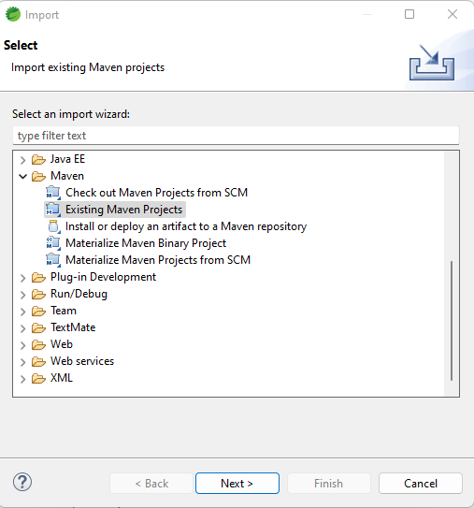
Let the project build automatically (when completes it will be notified in bottom right cornor.)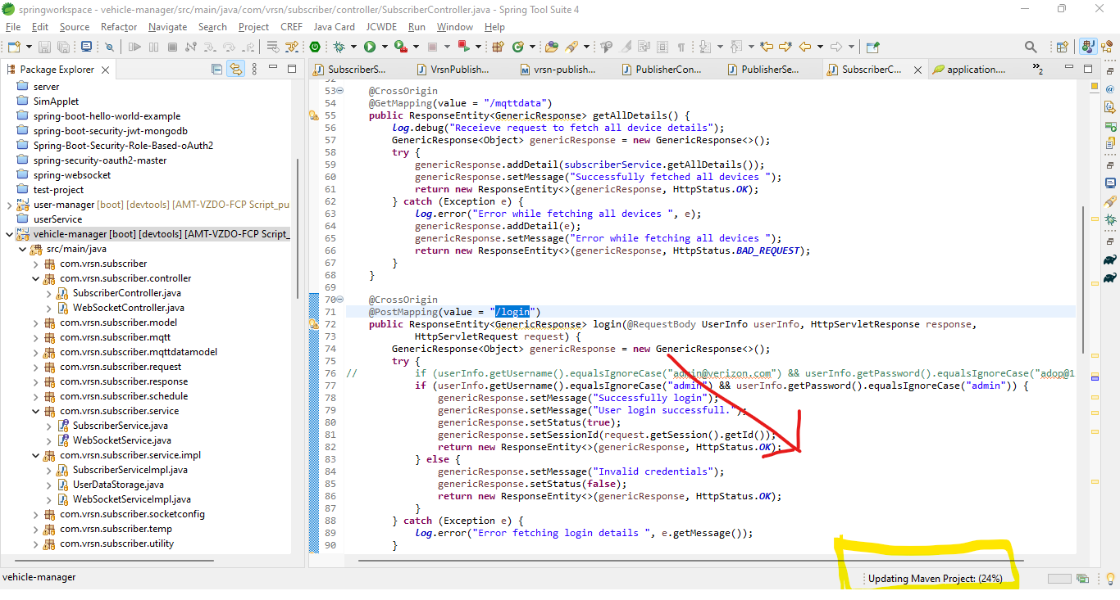
Build the service, use below commands:
mvn clean install
mvn spring-boot:run

Access, Authentication and Authorisation
As of current scenario, we are using hard coded username and password. After discussion with client and agreeing on common grounds that for this release we need not to provide authentication and authorization for APIs.
Below is the username and password:
Username: admin
Password: admin

Deployment
Deployment with Kubernetes is done. We will share the deployment document separately.

Frontend: ADOP-WEB

Version Details

Please document all changes made to this document since initial distribution.

Version | Amendment
1.0.0 | Dashboard User Interface with Map & Detail View. Map view to display the subscribed data from Verizon Server

Technology Used
- Angular 14.2.4
- Node js 16.17.0
- Ngnix

Setup

Step 1: Install node using https://nodejs.org/en/download/

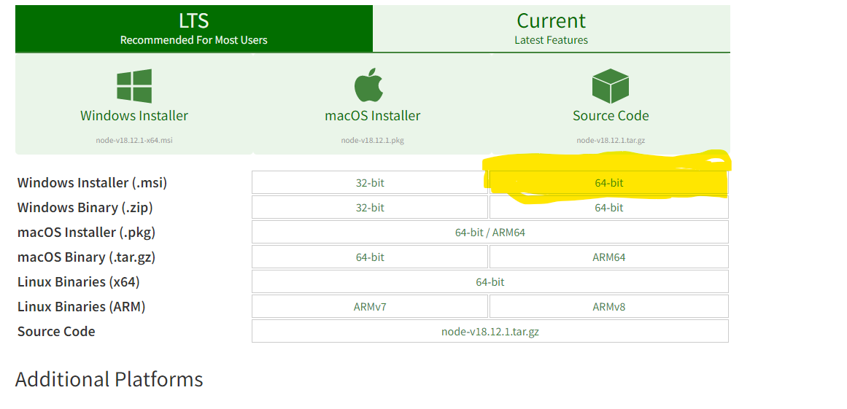

Step 2: Install downloaded .msi file.

Step 3: setup the path in environment variable.
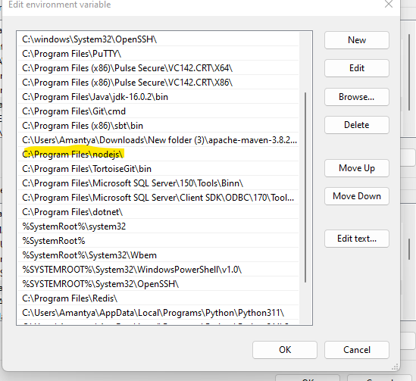

Step 4: Clone the project using below git command:
Git clone https://github.com/5GRealityLab/do_dashboard_ui.git

Step 5: Checkout development branch using
Git checkout main

Step 6: Pull the latest code
git pull

Step 7: cd hum-verizon-ui

Step 8: Install all the packages, using below command
npm install -f

Step 9: Start the server using below command
npm start

Step 10: Open browser, go to localhost:4200/

Step 11: Run ng build command to get the deployable output in dist folder.

Frontend: Description

Apply Button: After entering URL, username and password, user clicks Apply button to establish MQTT connection.
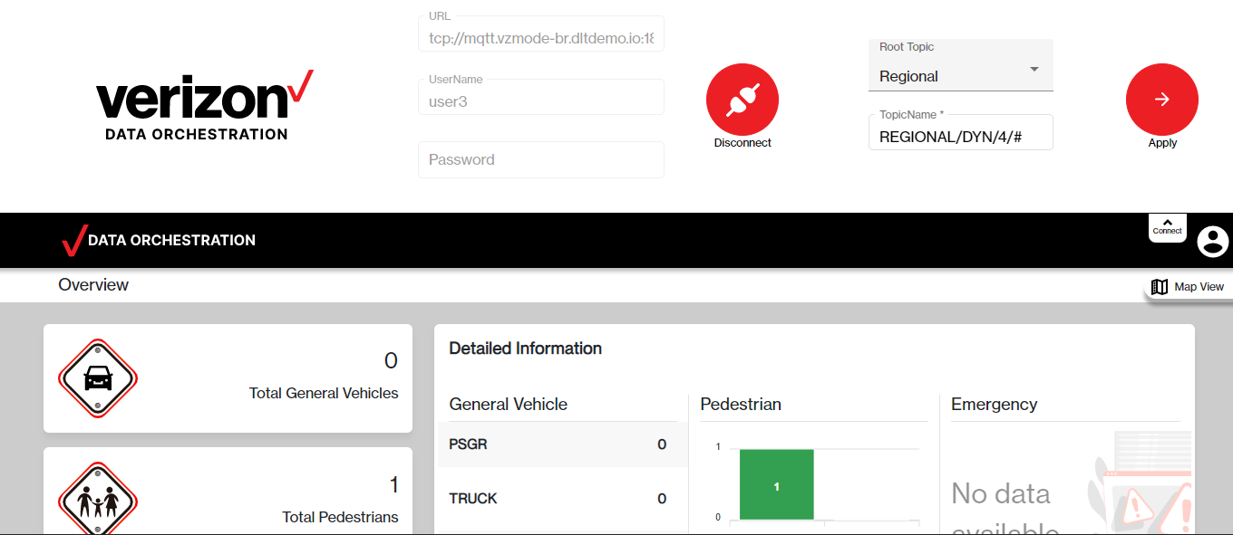
After successful connection, user will see the below screen
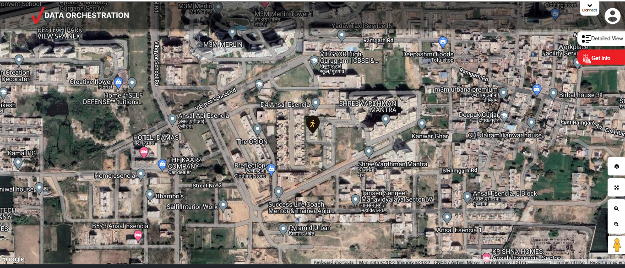
It contains the 2 views:
- Detailed view
- Get Info
- Signal Locator
Detailed view:
If user clicks on detailed view, user will able to see the below screen:
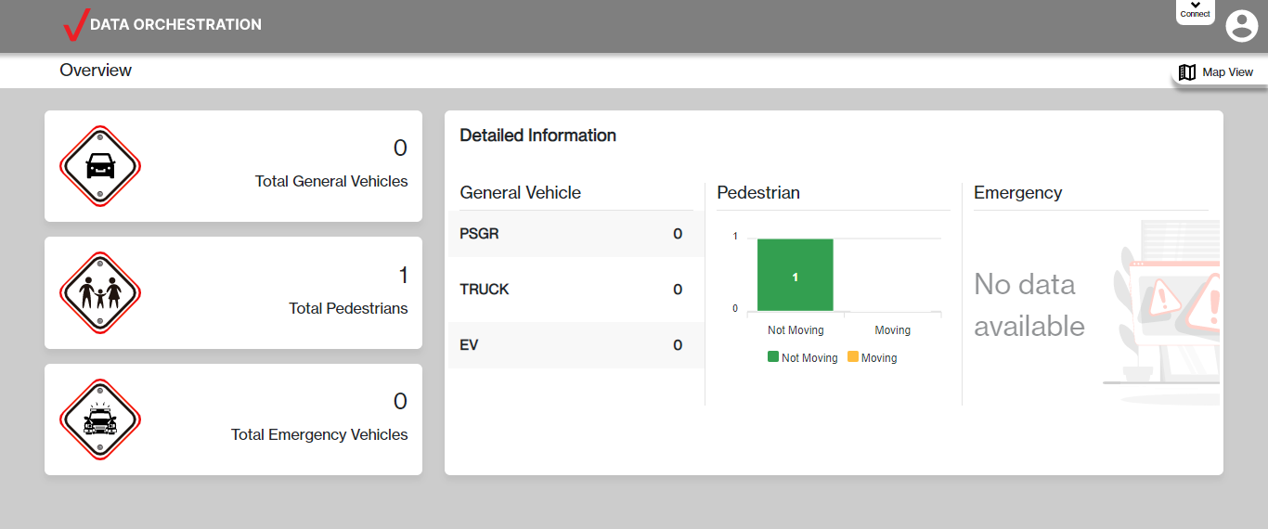
Above view contained the count information for general vehicles, total pedestrian and total emergency vehicles.
It also contains the information of the emergency vehicle along with the address or last location of the vehicle.
Get Info:
After selection of this section, user gets the below view with multiple options.
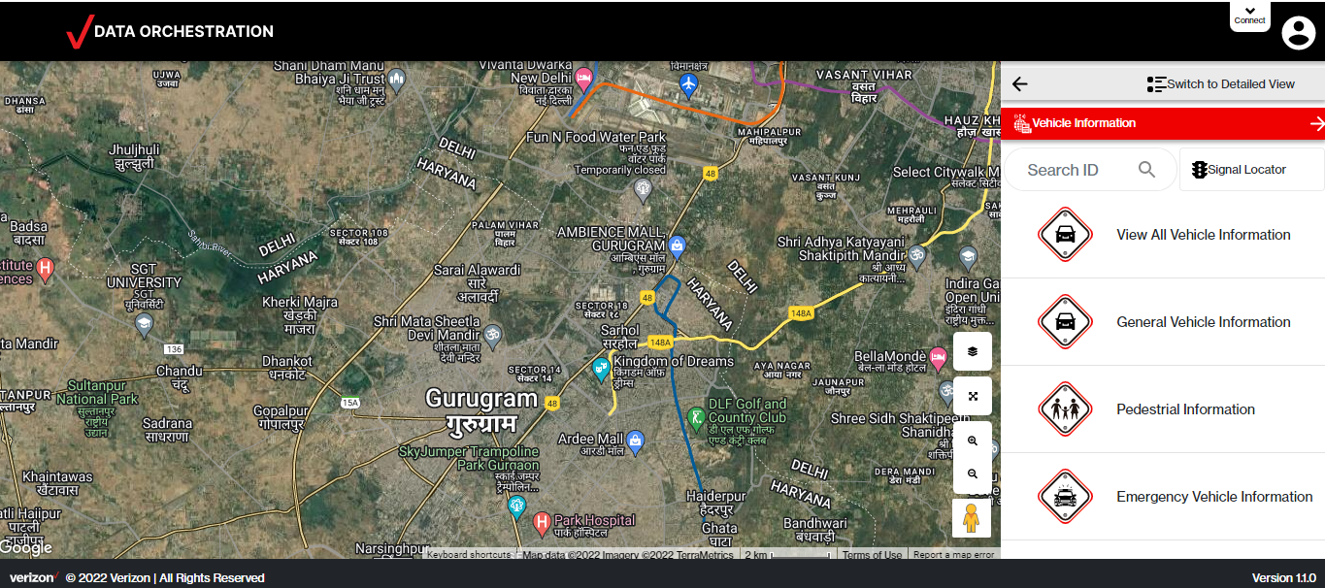
- View All Vehicle Information: This gives information of all types of vehicles, whether its general, emergency vehicle or pedestrian information.
- General Vehicle Information: This only filters out the data for the general vehicle, which technical contains all the BSM type messages from the MQTT. (For more info. Section 2.3)
- Pedestrian Information: This only filters out the data for the pedestrian, which technical contains all the PSM type messages from the MQTT. (For more info. Section 2.3)
- Emergency Vehicle Information: This only filters out the data for the emergency vehicle like ambulance, which technical contains all the EVA type messages from the MQTT. (For more info. Section 2.3)

Signal Locator:
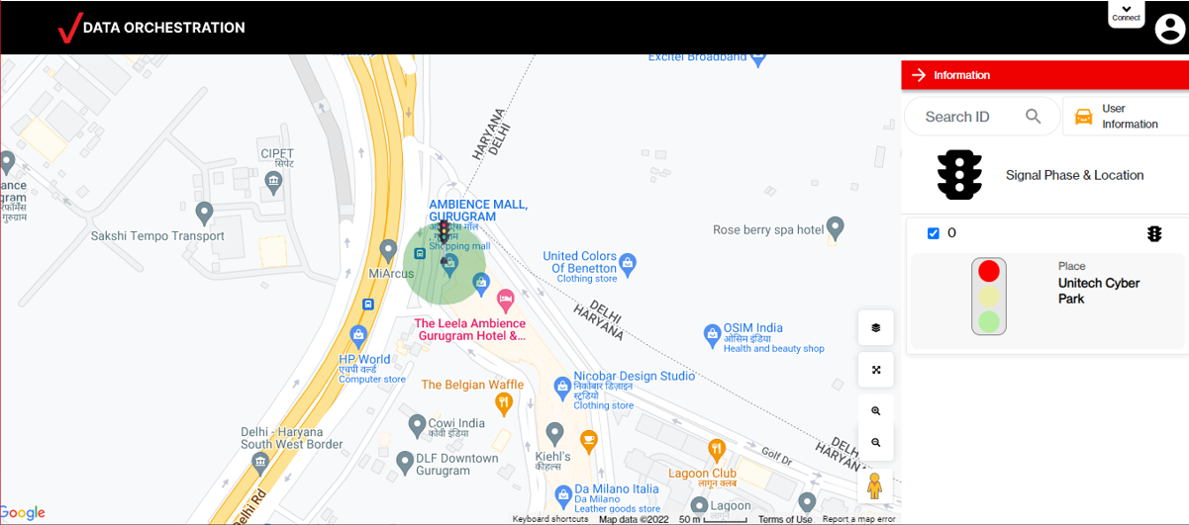
- In signal locator panel we can see all data regarding traffic signals
- It will interpret the SPaT data from MQTT
- We also can see the live signal status.

Communication flow in ADOP-WEB
Step 1: User login to the dashboard UI using username and password.
Step 2: Frontend makes HTTP request by using REST endpoint, to established connection to MQTT with predefined username and password.
REST Endpoint: /vrsu/api/subscriber/mqttConnectionCheck
Payload: {"username":"user3","password":"dfFg7sEX52BQ","url":"tcp://mqtt.vzmode-br.dltdemo.io:1883","sessionId":"CADF905EAC93835DC902090F03F5A936"}
Step 3: Frontend triggers the REST endpoint and subscribe to a specific topic.
REST Endpoint: /vrsu/api/subscriber/subscribeToTopic
Payload:{"topicName":"REGIONAL/DYN/3/#","sessionId":"SESS_ID","filterName":"ALL"}
Step 4: After successful Subscription to a topic, Frontend establish a web-socket connection using a REST endpoint.
REST Endpoint: : /vrsu/ws/info?t=CONNECTION_ID
Step 5: Backend receives that message through MQTT callback event and send the decoded message data to frontend using WebSocket connection established in step 4

Transaction Between Dashboard UI & Backend
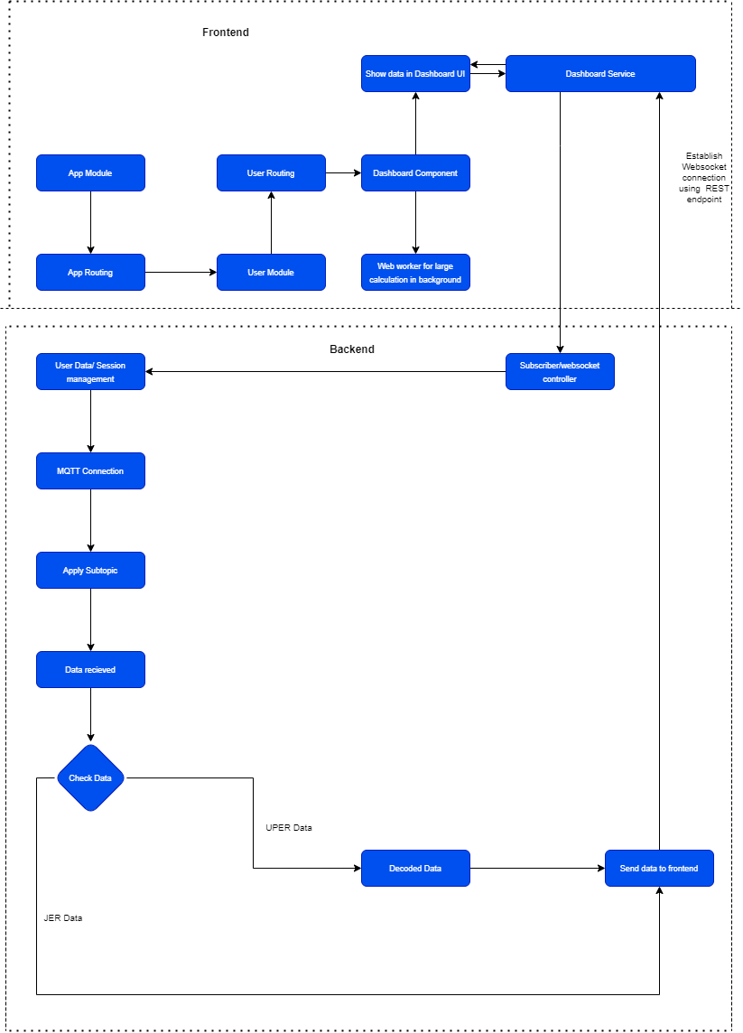

Format Of Messages After Decoding
As mentioned in Section 5.5 step 6, Messages are being decoded from backend and sent to Frontend through web-socket connection. Below are the structures of various messages along with the field that are being used in frontend.
After decoding we get data in string format which we parse and store in a json object as below:
JsonObject jsonObjectOutput = (JsonObject) jsonParser.parse(<Received_JSON_STRING>);
And this object we send to frontend, then frontend gets the data format as below:
- PSM: Personal Safety message
Description of the fields of above attached PSM data, that are being consumed by frontend.
Field Name | Value | Use Case
id | 000006A9 | Data id to show in UI.
position | {  "lat": 284434417,  "long": 770549838  } | Used for attaching marker in the map based on latitude and longitude.
speed | 0 | Speed of pedestrian.
heading | 67 | It shows in which direction a pedestrian is moving.
type | PSM | Type of data.

- BSM: Basic Safety Message
Description of the fields of above attached PSM data, that are being consumed by frontend.
Field Name | Value | Use Case
id | 000006A9 | Id of the vehicle to be shown in UI.
speed | 0 | Speed of a vehicle.
heading | 71 | It shows in which direction a vehicle is moving.
type | BSM | Type of data
subtype | TRUCK | Subtype of a vehicle
topicType | JER | Topic type eg. JER/UPER

- EVA: Emergency Vehicle Alert
Description of the fields of above attached PSM data, that are being consumed by frontend.
Field Name | Value | Use Case
position | "long": "770549925",  "lat": "284434419", | Used for attaching marker in the map based on latitude and longitude.
heading | 66 | It shows in which direction a vehicle is moving.
speed | {  "speed": "0"  } | Speed of a vehicle.
id | 000006A9 | Id of the vehicle to be shown in UI.
type | EVA | Type of data
topicType | JER | Topic type eg. JER/UPER

- SPaT: Signal Phase and Timing
Description of the fields of above attached PSM data, that are being consumed by frontend.
Field Name | Value | Use Case
id | 731 | ID to match with MAP data to get lat, long from MAP data.
signalGroup | 2
state-time-speed | {"eventState":"protected-Movement-Allowed",  "timing":{  "minEndTime":33897,  "maxEndTime":34057,  "likelyTime":33977,  "confidence":15} | Used for showing signal lights status.
type | SPAT | Type of data

- MAP: Used for symbolic representation of selected characteristics of a place.
Description of the fields of above attached PSM data, that are being consumed by frontend.
Field Name | Value | Use Case
name | Unitech Cyber Park | Used for showing the traffic signal place name in UI.
refPoint | {"lat":285059028,"long":770957442} | To get the exact location of traffic signal for drawing marker in map.
type | MAP | Type of data

Details of Google APIs
We are also using google APIs for geocoding and showing maps.
To do so we need a valid key for google API, which we can get from google account.
To set up the google key we have add below section in angular app.module.ts file
imports: [

AgmCoreModule.forRoot({
apiKey: 'API_KEY',
libraries: ['places', 'drawing', 'geometry'],
}),
],

Below are the APIs that we are using:
google.maps.MapTypeId : This API is used to show the map of different type for ex. Roadmap or hybrid.
google.maps.Geocoder : This is used to get the address from the latitude and longitude value.

Deployment
Step1: Download putty and import the attach file in the machine details to get connected to ubuntu machine. Configuration of ubuntu machine should be:
16GB RAM, 8 Core processor

Step2: After connecting to ubuntu machine, go to below mentioned path:
/var/recovery_disk/home/ubuntu/production_deployed_backend/frontend

Step3: Create a docker file with below code at this path.
FROM nginx:1.17.1-alpine
COPY nginx.conf /etc/nginx/nginx.conf
COPY /dist/adop-web /usr/share/nginx/html

Step4: Create an ngnix file at the same location with below code

events{}
http {
include /etc/nginx/mime.types;
server {
listen 80;
server_name localhost;
root /usr/share/nginx/html;
index index.html;
location / {
try_files $uri $uri/ /index.html;
}
}
}

Step5: Paste the dist folder at the same location which we got after running the ng build command over the repository.For further details got to section 2.2 step 11.

Step6: Run the following command to deploy the web application on server
docker build -t adop-web .
docker run --name adop-web -d -p 8081:80 adop-web

Map & SPAT Data Creation Summary
1.Create parent MAP
- 1. Reference point at center of intersection
- 2. Verified point at known accurate location
- 3. Configure intersection data (name, speed limit, etc.)
- 4. Save file to computer
2. Create child MAP
- 1. Load parent MAP created in 1
- 2. Draw vehicle lanes connecting to intersection, from stop bar backwards
- 3. Group vehicle lanes into approaches
- 4. Draw crosswalks
- 5. Fill in vehicle lane details
- 6. Fill in approach details
- 7. Fill in crosswalk details
- 8. Configure “connects to” values and signal groupings for all vehicle lanes
- 9. Save file to computer

